**CHAPTER 7**

**PREDICTION OF NEW CRIMINALS**

Forpredicting a “crime” which are committed by non-existing criminals, in a completely different area, where crime did not take place at all, we need to analyze hidden patterns among different types of crimes.

**7.1 Apriori Algorithm**

Apriori Algorithm recognizes Hidden Patterns by considering different attributes in the dataset and provide their occurrence and confidence levels based on their associativity between the attributes.

**Algorithm:**

Ck = candidate itemset of size k.

Lk = frequent itemset of size k.

L1 = {frequent items }

k=1

while (Lk )

{

Ck+1 = candidates generated from Lk .

For(each transaction)

Increment count of candidates in Ck+1

Lk+1 = candidates in Ck+1 with sufficient support

k=k+1

}

1. Support itemset frequency.
2. Confidence X $→$ Y

Conf(X $→$ Y)=supp(XY)/supp(X) i.e P(Y/X)

1. Lift association of X and Y.

Lift(XY)= supp (XY) / (supp(X) * supp(Y))

1. Conviction X $→$ Y

Conv(X $→$ Y) =(1-supp(Y)) / (1-conf(X $→$ Y))

|  |  |  |  |  |
| --- | --- | --- | --- | --- |
| **Crime** | **Occurrence** | **Support** | **Confidence** | **Lift** |
| Gambling | Game/Dice | 66.12 | 44.35 | 1.345 |
| Gambling | Sidewalk | 33.056 | 45.71 | 1.0 |
| Gambling | 6PM-8PM | 13.78 | 13.78 | 1.001 |
| Prostitution | Street | 90.35 | 90.35 | 1.01 |
| Prostitution | Solicit on public way | 74.28 | 67.87 | 1.011 |
| Prostitution | 8PM-10PM | 11.438 | 11.438 | 1.00 |
| Burglary | 1AM-3AM | 80.54 | 74.91 | 1.45 |
| Arson | Public buildings | 20.00 | 19.771 | 1.0 |
| Arson | Abandoned vehicles | 35.20 | 35.20 | 1.01 |

**Table 4. Hidden Pattern Recognition using Apriori Algorithm.**

**7.2 RFM Model**

After analyzing the results from the apriori algorithm we need to predict the occurrence of crimes based on various parameters like the criminal's frequent visits, recent activities of possible crime matching patterns and his/her genuinity. This can be successfully implemented using the well known RFM(RECENCY FREQUENCY MONETARY) prediction model. This is advisable because it clearly incorporates all the functionalities necessary for the accurate prediction at the moment. The person's most frequent locations are recorded in real time and this serves as the basic dataset for the prediction. The locations are categorized based on the person .These locations are fed to the prediction model and if they are found to be harmonious with some of the recorded crime patterns then they are shortlisted for possible crime action. There are two exceptions in which a person may be exempted even if found intriguing. They are based on the third parameter of "REASON".If the reason for visit is found to be in one of the two categories of

* HOME
* WORK

These two entries eliminate the need for the possibility of a criminal action. Such reasons find their place in the 'safe zone' of criminal prediction.

|  |  |  |
| --- | --- | --- |
| **Attribute** | **Data type** | **Description** |
| NAME | VARCHAR | Name of the person |
| ID | INTEGER | Unique id of the person |
| LOCATION DES. 1 | VARCHAR | General Place at time 1 |
| TIME 1 | TIME | Time in hrs at time 1 |
| BLOCK 1 | VARCHAR | Block address at time 1 |
| LOCATION DES. 2 | VARCHAR | General Place at time 2 |
| TIME 2 | TIME | Time in hrs at time 2 |
| BLOCK 2 | VARCHAR | Block address at time 2 |
| LOCATION DES. 3 | VARCHAR | General Place at time 3 |
| TIME 3 | TIME | Time in hrs at time 3 |
| BLOCK 3 | VARCHAR | Block address at time 3 |

**Table 5.Dynamic Dataset Attributes**

**7.3 Pictorial Authentication**

LabVIEW: Laboratory Virtual Instrument Engineering Workbench (LabVIEW) is a system-design platform and development environment for a [visual programming language](https://en.wikipedia.org/wiki/Visual_programming_language) from [National Instruments](https://en.wikipedia.org/wiki/National_Instruments). It is Image Visualization software which plays an important role in the pictorial authentication of the criminal. There are two cases of image verification; firstly the static images serve as the input to the system. In this case the image obtained is compared to find out a match with the criminal database. The next case is that CCTV footages serve as the input to the system, since the system tracks real time criminal activity based on the crime predicted pattern. LabVIEW makes it possible in extracting the facial image out of a taped record version of the real time activity.

LabVIEW has pre-defined modules for image processing which provides optimized results for verifying and processing the image. LabVIEW requires two module namely NI Vision Acquisition Module and NI Vision Development Module for Image Processing.

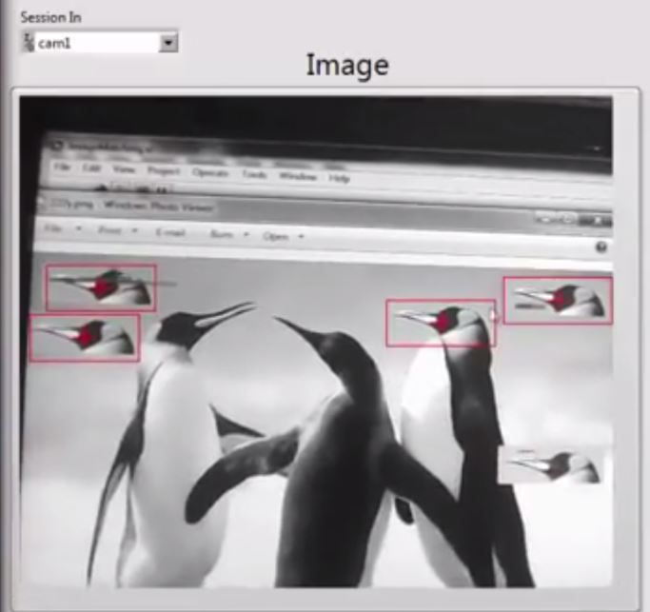

**Fig 2. Relative Image Authentication of a Static Image**

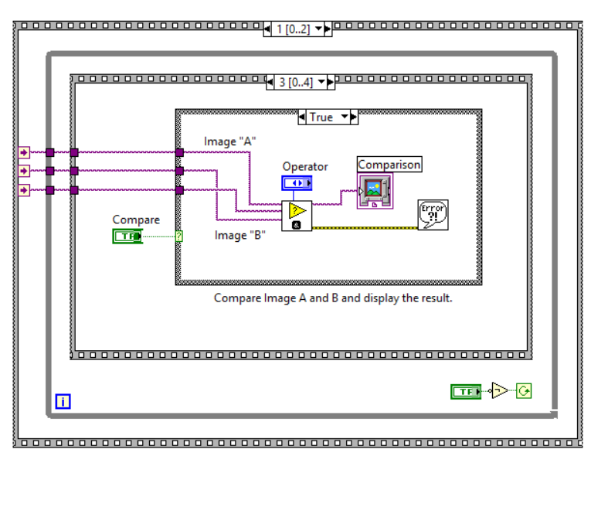

**Figure: Source Code for Image Verification in ‘G’ Language**

**7.4 Database Integration**

The results of the prediction are incorporated into a MYSQL database which serves as the backend for the webpage and the android application. There are thirty different tables in the database each denoting a particular type of crime.